國立中山大學教務處教學發展與資源中心
影音類數位教材拍攝服務申請單
Application Form for Audio-visual Digital Teaching Material Filming Service, Teaching and Learning Development and Research Center

影音類數位教材名稱
Audio-visual Digital
Teaching Material Name
攝製時間  Filming Time |  | 年 月 日 時 分  Year Month Day Time | 攝製地點  Filming Location
申請單位  Application Unit |  |  | 申請人姓名  Applicant Name | 姓名(Name)：  電話(Telephone)：  電郵(Email)：
申請項目  Application Items  (可複選)  ( Multiple Choice) |  | □數位教材拍攝Digital Teaching Material Filming  □數位教材後製剪接Digital Teaching Materials Post-production Editing
申 請 單 位Application Unit |  |  | 承辦單位 Administrative Unit
申請人  Applicant | 單位主管  Unit Supervisor |  | 承辦人  Contact Person | 承辦單位主管  Unit Supervisor
      - 本中心支援影音類數位教材拍攝之服務，以該時段無其他數位課程製作進行課堂實地拍攝為原則。The Center provides audio-visual digital teaching materials filming service based on the principle that there are no other digital course production filming at the same time.
      - 申請本中心支援影音類數位教材拍攝，須於拍攝時間前一星期填寫申請表格並經申請單位主管核章後，送交本中心審查同意，方可借用。
In applying for TLDR’s audio-visual digital material filming service, applicants must fill out this form providing supervisor’s signature and submit to TLDR for review one week prior to the filming time.
      - 製作所需之耗材(如光碟等)由申請單位提供。
Materials required for the production (CDs, etc.) should be provided by the application unit.
      - 本表所附之授權同意書，係指申請單位或授課者同意將相關影像類數位教材放置本中心數位平台，請於攝製結束後交由本中心數位教學助理攜回本中心存查。
This application form is attached with a letter of consent, which authorizes TLDR to upload the digital teaching materials to TDLR’s digital platform. Please provide the letter to the digital learning crew after the filming.

附表
授權同意書
Authorization Consent Form

- 茲同意將本人錄製之課程/演講：「 」非專屬、無償授權國立中山大學，包含演講內容、問題討論、使用講義與素材、宣傳資料等與演講相關之著作及本人肖像 (下稱授權內容)，國立中山大學得不限時間與地域將授權內容重製 (包含且不限於以電子形式儲存、紙本抄錄)、製作/改作/編輯/後製、發行、公開口述、公開播送、公開傳輸、公開上映、公開演出、再授權及為研究、教育目的下之任何利用(包含且不限於演講全程影音錄製與場外轉播、授權內容數位化、將授權內容於課堂上播放或以紙本散布、將授權內容以光碟形式或電腦網路連結等方式整合於國立中山大學校內或校外合作之相關實體或數位平台/載體/刊物)。
I hereby gratuitously authorize National Sun Yat-sen University the non-exclusive license of my lectures, discussions, handouts and materials, promotional materials, other works related to the lecture, and photography and recordings (hereinafter referred as licensed content). NSYSU has the right to reproduce (including and not restricted to electronic storage, paper transcription), produce, adapt, edit, post-produce, issue, publicly narrate, publicly broadcast, publicly transmit, publicly release, publicly perform, re-authorize, and make use of the authorized content for research and education purposes (including and not restricted to the recording of the entire process and off-site broadcasting, digitalization of the authorized content, playing the authorized content in class or distributing it through hard copy, integrating the authorized content in NSYSU’s physical and digital platforms, media, and publications and those external physical and digital platforms, media, and publications in cooperation with NSYSU).
- 本人同意國立中山大學採用創用 CC 授權「姓名標示－非商業性－相同方式分享」3.0版台灣授權條款釋出。
I agree that NSYSU can release the Creative Commons license of the authorized content under Creative Commons Attribution-Noncommercial-Share Alike 3.0 TW.

- 姓名標示：您必須按照著作人或授權人所指定的方式，表彰其姓名（但不得以任何方式暗示其為您或您使用本著作的方式背書）。
Attribution—Licensees may copy, distribute, display, perform and make derivative works and remixes based on it only if they give the credit (attribution) the way specified by the author or licensor (but should not hint in any way at the endorsement of how the work is used).
- 非商業性：您不得為商業目的而使用本著作。
Non-commercial—Licensees may copy, distribute, display, perform the work and make derivative works and remixes based on it only for non-commercial purposes.
- 相同方式分享：若您變更、變形或修改本著作，您僅得依本授權條款或與本授權條款類似者來散布該衍生作品。
Share-alike—Licensees may distribute derivative works only under a license identical to the license that governs the original work.

- 本人聲明對授權內容擁有著作權及合法使用之權利，並得為此同意 書之授權。
I declare my copyright and right to fair use of the authorized content, and I authorize them with this letter.
- 本人保證授權內容並無侵害他人智慧財產權、隱私權及其他權利之情事。如有危害他人權益及觸犯法律之情事發生，本人願自負一切法律上責任，並提供國立中山大學一切必要之協助。
I guarantee that the authorized content does not infringe on others’ intellectual property, privacy, and other rights. If others’ rights or laws are violated, I will assume the legal liability and provide National Sun Yat-sen University with full necessary assistance.

立授權書人： (簽名)
Authorizer: (Signature)
年 月 日
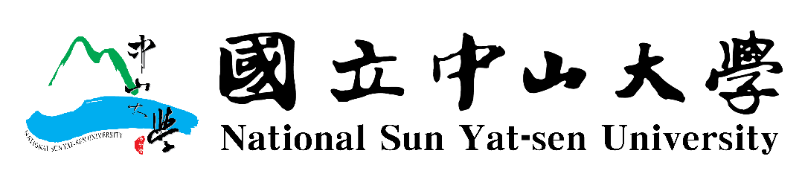
Year /Month / Day

